SOURCE-VERIFIED EMBEDDED ADC GUIDE
ADS1115 Continuous Conversion Mode
Simple Explanations, Internal ADC Behavior, Latest-Sample Timing, Integer Scaling, Finalized Source, and Engineering Review
Document purpose: Understand what the ADS1115 does after continuous mode is started, how often new data appears, what the Conversion register stores, and how the attached STM32F4 driver reads and displays the latest AIN0 value.

Coverage | This edition explains
Mode | AIN0 single-ended, +/-4.096 V, continuous conversion, 128 SPS
Key idea | Write Config once; the ADC keeps converting by itself
Data behavior | One latest-result register, no FIFO, repeated/skipped samples depending on read rate
Math | Signed raw code -> microvolts -> rounded millivolts
Source | Six attached C/H files are the implementation authority
Reference depth | Functional modes, timing, reconfiguration, power, noise, ALERT/RDY, and limitations

1. Document Control and Source Scope
Item | Value
Document type | ADS1115 continuous-mode source-verified learning reference
Implementation authority | Attached ads1115.c/.h, i2c.c/.h, main.c/.h
Learning narrative | Attached continuous-mode chat
Device reference | TI ADS111x datasheet SBAS444E
Design | compact_reference_guide with editorial cover
Generated | 10 July 2026
Footer | Embedded Learning Document

2. Files Read
File | Role | SHA256 prefix
ads1115.c | Continuous start/stop, raw read, integer conversion, UART test | 4bc2af939b8accdb...
i2c.c | STM32F4 I2C1 polling backend | 12116366d7dd2f2a...
main.c | Current application integration and active one-shot loop | 789ae9628f4fe072...
ads1115.h | Continuous Config/LSB macros and public APIs | 4afe01d3b3b36e18...
i2c.h | Generic I2C APIs and timeout macro | d779de638d9b500b...
main.h | Application/HAL header and Error_Handler declaration | e07a43ebc634ce45...

3. Learning Objectives
- Explain continuous mode using simple producer-and-reader language.
- Understand why Config is written once and Conversion is read many times.
- Decode the difference between 0xC383 and 0xC283.
- Understand what happens when the MCU reads faster or slower than 128 SPS.
- Follow the exact continuous-mode functions in the attached source.
- Understand integer microvolt-to-millivolt conversion and rounding.
- Know the current integration status, limitations, and next improvements.

4. Project Objective and Implementation Status
The driver now contains functions to start AIN0 continuous conversion, read the latest signed result, convert it to millivolts, print it, and return the device to single-shot/power-down mode. However, the attached main.c still calls ADS1115_Test_AIN0() in its main loop. Therefore the continuous driver is implemented, but it is not the active application path in the attached main.c.
Source truth: ADS1115_TestContinuous_AIN0() is a complete demonstration loop inside ads1115.c. If it is called, it does not return because it contains while(1). ADS1115_StopContinuous() therefore cannot be reached from that test function without changing the control structure.

5. System Overview
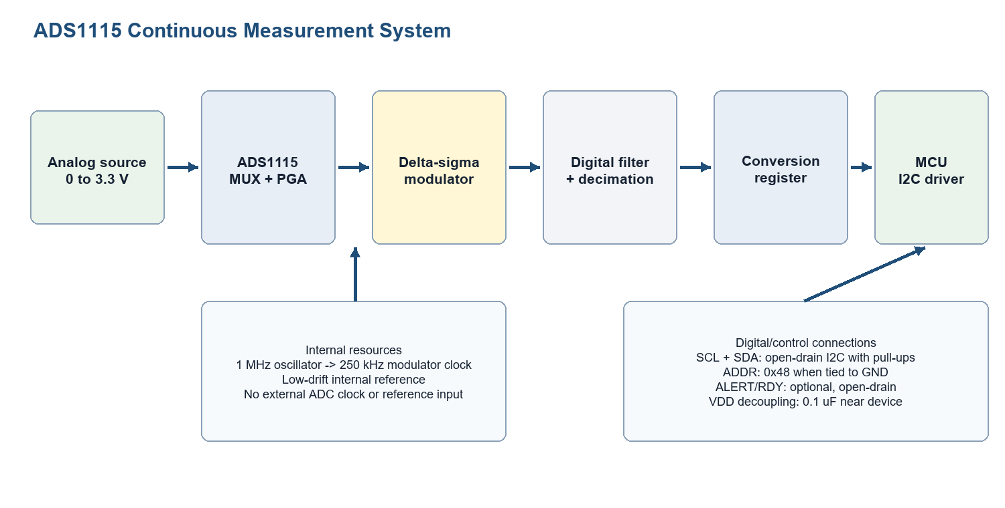
Figure 1. ADS1115 analog and digital signal path.

5.1 Think of Continuous Mode as a Producer
The ADS1115 is the producer. After the MCU writes 0xC283, the ADC keeps making one new sample after another. The MCU is the reader. It can read the Conversion register whenever the application needs a value. Reading does not start, stop, or pause conversion.

6. Single-Shot Versus Continuous Mode
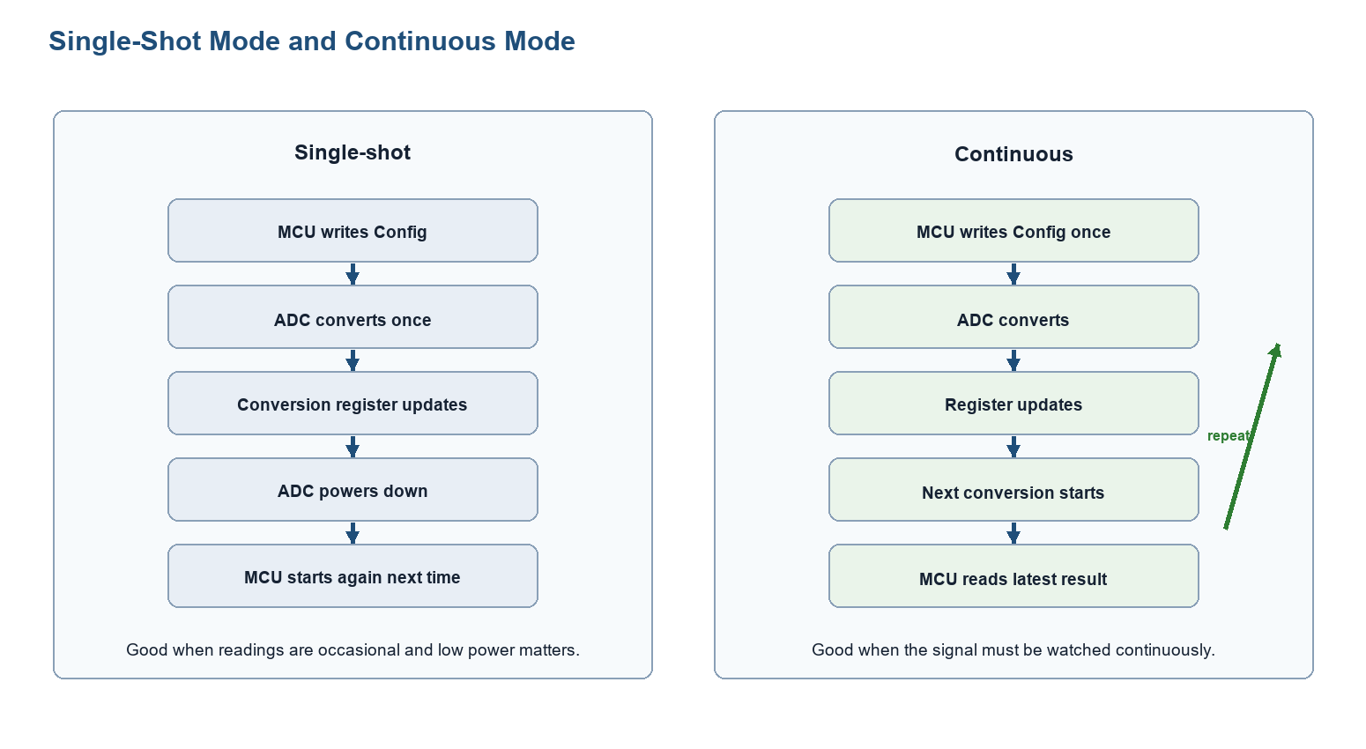
Figure 2. How the two conversion modes differ.
Question | Single-shot | Continuous
How conversion starts | Write OS=1 for each reading | Write MODE=0 configuration once
After a conversion | Device returns to power-down | Next conversion starts immediately
What MCU reads | The requested completed result | Latest completed result
Power | Lower when readings are spaced apart | ADC remains active
Best use | Occasional measurements | Regular monitoring

6.1 What Changes in Config
Config | Binary | MODE bit 8 | Behavior
0xC383 | 1100 0011 1000 0011 | 1 | Single-shot / power-down
0xC283 | 1100 0010 1000 0011 | 0 | Continuous conversion

Simple rule: Only MODE changes between these two project constants. MUX, PGA, data rate, and comparator settings stay the same.

7. What the ADS1115 Does Internally
- The MUX selects AIN0 relative to GND.
- The PGA sets the measurement scale to +/-4.096 V.
- The delta-sigma modulator samples internally at a high rate.
- The digital filter removes high-frequency noise and decimates the data.
- At 128 SPS, one completed result appears about every 7.8 ms.
- The result replaces the old value in the Conversion register.
- The next conversion begins immediately.

7.1 Single-Cycle Settling
The datasheet says a conversion settles within one output-data-rate cycle. This means the first completed result after the new continuous configuration uses the new settings; the source waits 10 ms before reading, which is longer than the nominal 7.8125 ms cycle at 128 SPS.

7.2 Changing Settings While Continuous Conversion Is Running
If software writes a new MUX, PGA, or data-rate setting while a conversion is already running, the current conversion finishes with the old settings. Continuous conversions with the new settings begin after that. This matters when switching channels: label each result with the configuration that produced it.

8. Latest-Sample Register: No FIFO
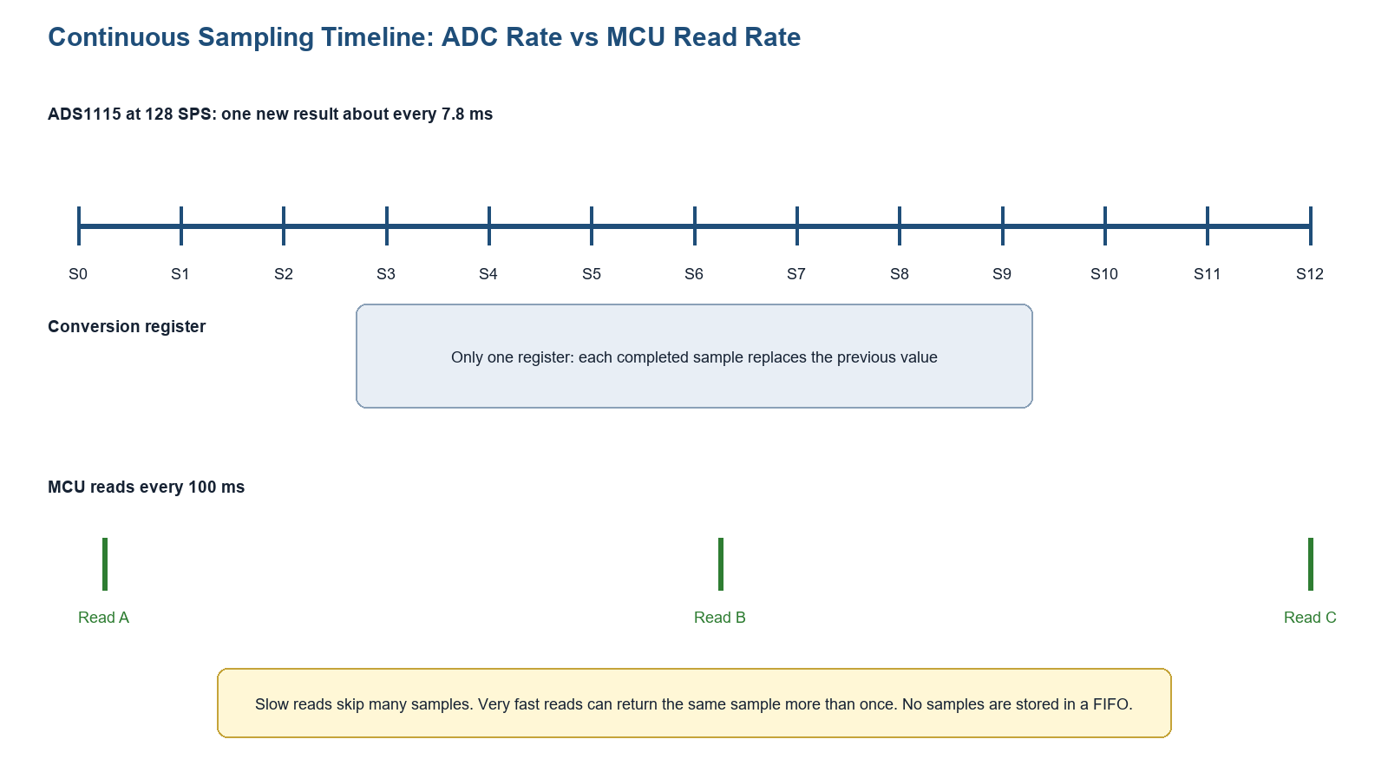
Figure 3. Relationship between the 128 SPS producer and the 100 ms reader.
The ADS1115 has one Conversion register, not a queue of samples. Every completed conversion overwrites the previous result. At 128 SPS, roughly 12 or 13 conversions occur during the source's 100 ms UART delay. The next read returns only the newest completed result; intermediate results are not saved.
MCU read interval | What happens
Faster than 7.8 ms | Some reads return the same conversion value again
About 7.8 ms | Approximately one read per new result, but scheduling/tolerance still matter
100 ms (source test) | Many conversions occur; only the latest result is displayed
No reads | ADC still converts and overwrites the Conversion register

9. Data Rate, Noise, and Power
Data rate | Nominal cycle | Simple meaning
8 SPS | 125 ms | Slowest; strongest internal averaging
128 SPS | 7.8125 ms | Implemented balance of speed and stability
860 SPS | About 1.163 ms | Fastest; generally more noise

Lower data rate gives the digital filter more internal samples for each output result, so noise generally improves. Continuous mode keeps the ADC active; the datasheet lists about 150 microamps typical continuous-mode current. Single-shot mode can save power because the ADC powers down between requests.

9.1 ALERT/RDY as a Better Fresh-Data Signal
The ADS1115 can use ALERT/RDY as a conversion-ready output. In continuous mode it can produce an approximately 8 microsecond ready pulse after each conversion. The current source disables the comparator/ALERT output, so it uses fixed delays instead. ALERT/RDY is the natural next step when every new sample matters.

10. Raw Code and Integer Voltage Conversion
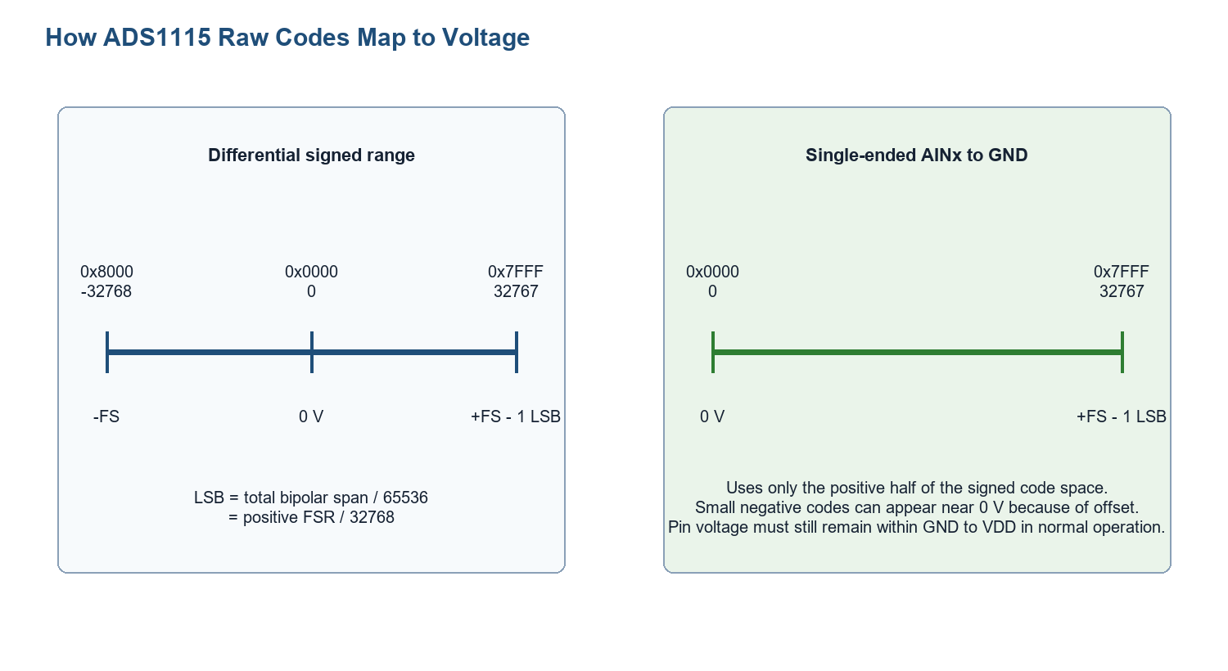
Figure 4. Signed code range and single-ended positive range.
Step | Implemented operation | Reason
Read raw | Cast 16-bit register to int16_t | Preserve two's-complement sign
Clamp | If raw < 0, set raw = 0 | Hide small negative offset/noise for single-ended display
Scale | voltage_uV = raw * 125 | PGA +/-4.096 V gives 125 uV/LSB
Round | (voltage_uV + 500) / 1000 | Convert microvolts to nearest millivolt
Print | %u.%03uV | Show integer and three decimal digits

10.1 Worked Example
raw = 26080
voltage_uV = 26080 x 125 = 3,260,000 uV
voltage_mV = (3,260,000 + 500) / 1000 = 3260 mV
printed value = 3.260 V
Important: The 125 uV constant is correct only for the current +/-4.096 V PGA setting. A future generic PGA API must choose the matching LSB automatically.

11. Finalized Continuous-Mode Macros
#define ADS1115_CONFIG_AIN0_SINGLE_4V096_128SPS 0xC383U
#define ADS1115_CONFIG_AIN0_CONT_4V096_128SPS 0xC283U
#define ADS1115_LSB_4V096_UV 125

11.1 Config 0xC283 Field Decode
Bits | Field | Value | Meaning
15 | OS | 1 | Written high; continuous operation is selected by MODE=0
14:12 | MUX | 100 | AIN0 to GND
11:9 | PGA | 001 | +/-4.096 V
8 | MODE | 0 | Continuous conversion
7:5 | DR | 100 | 128 SPS
1:0 | COMP_QUE | 11 | Comparator/ALERT disabled

12. Exact Continuous-Mode Source Functions

12.1 Start Continuous Conversion
uint8_t ADS1115_StartContinuous_AIN0(void)
{
return ADS1115_WriteRegister(ADS1115_ADDR_GND,
ADS1115_REG_CONFIG,
ADS1115_CONFIG_AIN0_CONT_4V096_128SPS);
}
This writes Config once. The ADC then continues without another start command.

12.2 Stop Continuous Conversion
uint8_t ADS1115_StopContinuous(void)
{
return ADS1115_WriteRegister(ADS1115_ADDR_GND,
ADS1115_REG_CONFIG,
ADS1115_CONFIG_AIN0_SINGLE_4V096_128SPS);
}
This writes the single-shot configuration again. MODE becomes 1, so the device returns to single-shot/power-down behavior after the mode change takes effect.

12.3 Read the Latest Raw Value
uint8_t ADS1115_ReadContinuousRaw(int16_t *raw)
{
uint16_t reg_value;
if(raw == NULL)
{
return E_NOT_OK;
}
if(ADS1115_ReadRegister(ADS1115_ADDR_GND,
ADS1115_REG_CONVERSION,
&reg_value) != E_OK)
{
return E_NOT_OK;
}
*raw = (int16_t)reg_value;
return E_OK;
}

12.4 Convert Raw to Millivolts
uint8_t ADS1115_RawToMilliVolt_4V096(int16_t raw,
uint16_t *voltage_mV)
{
int32_t voltage_uV;
if(voltage_mV == NULL)
{
return E_NOT_OK;
}
if(raw < 0)
{
raw = 0;
}
voltage_uV = (int32_t)raw * ADS1115_LSB_4V096_UV;
*voltage_mV = (uint16_t)((voltage_uV + 500) / 1000);
return E_OK;
}

12.5 Combined Continuous Read
uint8_t ADS1115_ReadContinuous_AIN0(int16_t *raw,
uint16_t *voltage_mV)
{
if((raw == NULL) || (voltage_mV == NULL))
{
return E_NOT_OK;
}
if(ADS1115_ReadContinuousRaw(raw) != E_OK)
{
return E_NOT_OK;
}
if(ADS1115_RawToMilliVolt_4V096(*raw, voltage_mV) != E_OK)
{
return E_NOT_OK;
}
return E_OK;
}

12.6 Continuous UART Test
void ADS1115_TestContinuous_AIN0(void)
{
int16_t raw;
uint16_t voltage_mV;
char msg[100];
if(ADS1115_StartContinuous_AIN0() != E_OK)
{
USART2_SendString("ADS1115 continuous start failed\r\n");
return;
}
USART2_SendString("ADS1115 continuous mode started\r\n");
HAL_Delay(10);
while(1)
{
if(ADS1115_ReadContinuous_AIN0(&raw, &voltage_mV) == E_OK)
{
sprintf(msg,
"CONT AIN0 Raw = %d, Voltage = %u.%03uV\r\n",
raw,
voltage_mV / 1000U,
voltage_mV % 1000U);
USART2_SendString(msg);
}
else
{
USART2_SendString("ADS1115 continuous read failed\r\n");
}
HAL_Delay(100);
}
}

13. Implemented Test Flow
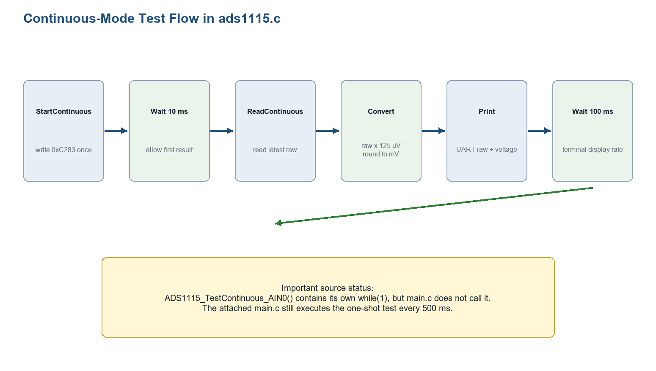
Figure 5. Continuous test loop implemented in ads1115.c.
- Write 0xC283 once to start continuous conversion.
- Wait 10 ms so the first 128 SPS result can complete.
- Read the latest Conversion register value.
- Clamp a negative single-ended display value to zero.
- Multiply by 125 microvolts and round to millivolts.
- Print raw code and voltage over USART2.
- Wait 100 ms, then repeat forever.

14. Current main.c Integration
//One shot ADC conversion
ADS1115_Test_AIN0();
HAL_Delay(500);
Implementation status: The continuous APIs are compiled and declared, but this is the active code in main.c. Continuous mode is not started by the attached application. Also, ADS1115_TestContinuous_AIN0() contains its own infinite loop, so calling it would take control of the program permanently.

14.1 Shared I2C Backend
Continuous mode does not need a new I2C driver. Start uses the existing three-byte register write. Each sample read uses the existing pointer-write plus two-byte register read. The STM32F4 two-byte branch sets POS, clears ACK, clears ADDR, waits for BTF, generates STOP, reads DR twice, and restores POS/ACK.

15. Testing and Expected Output
Test | Expected result
Start | ADS1115 continuous mode started
Stable input | Raw values stay near one code region; small noise variation is normal
Potentiometer movement | Latest raw/voltage follows the input on each 100 ms display read
Read faster than 7.8 ms | Some consecutive values repeat
Stop API | Writing 0xC383 returns device to single-shot/power-down behavior

ADS1115 continuous mode started
CONT AIN0 Raw = 26080, Voltage = 3.260V
CONT AIN0 Raw = 26079, Voltage = 3.260V
CONT AIN0 Raw = 14820, Voltage = 1.853V

15.1 Logic Analyzer Checkpoints
- One Config write uses pointer 0x01 followed by 0xC2 and 0x83.
- Later sample reads use pointer 0x00 followed by a two-byte read.
- No repeated Config write is needed for each sample.
- At the source's 100 ms interval, I2C reads occur much slower than ADC conversions.

16. Engineering Review
Finding | Source evidence | Meaning
Continuous mode not active in main | main calls ADS1115_Test_AIN0() | Driver exists but application still runs one-shot
Test function never returns | ADS1115_TestContinuous_AIN0() contains while(1) | StopContinuous cannot be used after entering this test loop
No sample freshness check | Reads are delay-based | A read can repeat or skip samples; ALERT/RDY would provide exact readiness
No FIFO | One Conversion register | Intermediate 128 SPS results are overwritten during 100 ms delay
Fixed channel/PGA/rate | 0xC283 and 125 uV macro | Simple and correct for this stage, not generic
Unbounded I2C waits | I2C_TIMEOUT is defined but not used | A bus fault can block the program
Integer conversion is robust | int32_t intermediate, rounding to uint16_t mV | Avoids float in continuous display path
Public declarations corrected | main includes ads1115.h; continuous APIs are declared | Earlier interface gap is resolved

16.1 Debugging Guide
Symptom | Likely cause | Check
No continuous message | TestContinuous not called | Inspect active main.c path
Same raw value repeated | MCU reading faster than new conversion or stable input | Compare read interval with 7.8 ms
Large jumps missing | 100 ms reads skip intermediate conversions | Use shorter interval or ALERT/RDY
Voltage scale wrong | PGA no longer +/-4.096 V | Match LSB macro to Config
Application frozen | Infinite test loop or I2C wait | Understand ownership of while(1); add timeouts
Small negative raw | Offset/noise near 0 V | Source clamps only the displayed single-ended voltage

17. Limitations and Future Improvements
- Continuous mode is AIN0-only with fixed +/-4.096 V and 128 SPS.
- The demonstration owns an infinite loop and is not integrated into main.c.
- There is no exact new-sample indication or sample counter.
- I2C waits have no timeout or bus recovery.
- Intermediate samples are not buffered.
- Integrate start once in initialization and perform non-blocking reads from the main scheduler.
- Use ALERT/RDY when each fresh sample must be processed.
- Add generic channel, PGA, and data-rate configuration with matching LSB conversion.
- Add a software ring buffer if every sample must be retained.
- Apply I2C_TIMEOUT to all bus waits and add recovery/error codes.
- Compare noise at 8, 128, and 860 SPS using minimum, maximum, mean, and peak-to-peak values.

18. Conclusion
Continuous mode is simple once its ownership is clear: the ADS1115 owns the conversion schedule, and the MCU only chooses when to read the latest completed result. The source correctly writes 0xC283 once, waits for the first conversion, reads the signed Conversion register, converts using 125 microvolts per count, and displays at a slower 100 ms rate. The most important next design decision is whether the application needs only the latest value or must process every fresh sample.

Appendix A. Quick Reference
Item | Value
Continuous Config | 0xC283U
Single-shot Config | 0xC383U
MODE continuous | 0
AIN0 MUX | 100
PGA | +/-4.096 V
LSB | 125 uV/code
Data rate | 128 SPS
Nominal cycle | 7.8125 ms
First wait | 10 ms
Display read interval | 100 ms

Appendix B. Source Hashes
File | SHA256
ads1115.c | 4bc2af939b8accdbc6ccba5bf7c52cb6b64dc5e763f4295127ae1f3ea426d435
i2c.c | 12116366d7dd2f2a673c3e4ef12be044023d90376f85c6a45fc883bd8314ec79
main.c | 789ae9628f4fe072a8e7db247da872526554224c037fcb4f0c8aa88fb2c80d90
ads1115.h | 4afe01d3b3b36e187b4d58cee47f4072c89cac2afbe0dd5dd04e0beb8620ec35
i2c.h | d779de638d9b500b62e14c5c11715621cf65f00db9761d72903c156e5d157f24
main.h | e07a43ebc634ce451e2f80884378d112e048e06235fb49fdc2d9a2b5057d28c5

Appendix C. Datasheet Reading Map
Section | Read for
6.1 | Noise, oversampling, effective resolution
7.3.3-7.3.6 | FSR, LSB, internal reference, oscillator, data rate
7.3.8 | ALERT/RDY conversion-ready output
7.4.2 | Single-shot and continuous functional modes
7.4.3 | Duty cycling and power trade-off
7.5 | I2C programming and register reads
8.1.3 | Config register fields

